ACKNOWLEDGEMENT

This project has been executed as a mandatory component of the Computer Science (Subject Code: 083) curriculum prescribed by the Central Board of Secondary Education. In accomplishing this academic requirement, I have earnestly assimilated conceptual understanding and analytical perspective cultivated through formal instruction and independent study. The creation of this work demanded disciplined organisation, intellectual depth, and sustained perseverance, rendering the process both rigorous and enriching.
I deem it a privilege to formally acknowledge the encouragement and assistance extended during this scholastic pursuit. I express my sincere gratitude to the Almighty for bestowing resilience, determination, and clarity of thought throughout the endeavour. I convey profound respect to our esteemed Principal, Ms. Jyotsna Ranjan, whose visionary leadership and consistent motivation fostered an environment conducive to academic growth. I am deeply obliged to my Computer Science Facilitator, Mrs. Sonia Shah, for her discerning mentorship, scholarly insight, and constructive guidance during the formulation of this assignment.
I also recognise the cooperation of the school administration, whose provision of essential resources and a supportive academic atmosphere enabled uninterrupted progress. I remain sincerely thankful to my parents and peers for their encouragement, thoughtful input, and moral reinforcement, which significantly contributed to the successful completion of this work.
This project stands as a reflection of the collective guidance, goodwill, and support received from all those acknowledged above.

CERTIFICATE

This is to certify that the project entitled “TimeTable Generator”. is a bonafide work done by Shubh of Class 12, (Academic session 2025-26). This project has been carried out under the direct supervision of Mrs. Sonia Shah.

……………………………………………… ……………………………………………
Signature of External Examiner Signature of Educator
[Mr. / Ms. ………………………………………………………]

……………………………………………………………………………
Signature of Student
CBSE Roll No. …………………………………………………

TABLE OF CONTENTS

- Aim of the Project 1
- Software and Hardware Requirements 2
- Tools and Technologies Used 3
- Project Description 4
- Algorithm 5
- Python Code 6-8
- Python Code Input 9
- Output 10-14
- Features of the Project 15
- Limitations of the Project 16
- Bibliography 17
- QR Code and Link 18

AIM OF THE PROJECT

The aim of this project is to design and develop a Python program that automatically generates school timetables for multiple classes while ensuring that no teacher is allotted to more than one class at the same time.

1
SOFTWARE AND HARDWARE REQUIREMENTS

- Minimum Software Requirements-

- Operating System: Windows 10
- Programming Language: Python 3.8
- IDE: Python IDLE
- Spreadsheet Software: Microsoft Excel 2016

- Minimum Hardware Requirements-

- Processor: Intel Pentium Dual Core
- RAM: 2 GB
- Storage: 50 MB free disk space
- Input Devices: Keyboard, Mouse
- Output Device: Monitor

2
TOOLS AND TECHNOLOGIES USED

- Python Programming Language – for developing the timetable generation logic
- CSV Module – for storing timetables in Excel-readable format
- Random Module – for random allocation of subjects
- Microsoft Excel – for viewing the generated timetable files

3
PROJECT DESCRIPTION

This project is an automated timetable generation system developed using Python. It allows the user to input subjects along with their respective teachers and automatically generates weekly timetables for multiple classes.
The program ensures that:
- Each class gets a complete timetable for all working days
- A fixed lunch break is included
- No teacher is assigned to more than one class in the same period
The generated timetables are saved in CSV format, making them easy to open, view, and edit using Microsoft Excel. This system reduces manual effort, minimizes errors, and ensures fair distribution of subjects and teachers.

4
ALGORITHM

- Start the program
- Input subjects and corresponding teacher names
- Store subject–teacher pairs using a dictionary
- Define days of the week and periods per day
- For each day:
- Generate a timetable for all classes
- Ensure lunch period is fixed
- Ensure no teacher is repeated in the same period
- Repeat the process until a valid timetable is generated
- Store class timetables in CSV files
- Generate separate teacher timetables
- Save teacher timetables in CSV files
- Stop the program

CODE
5
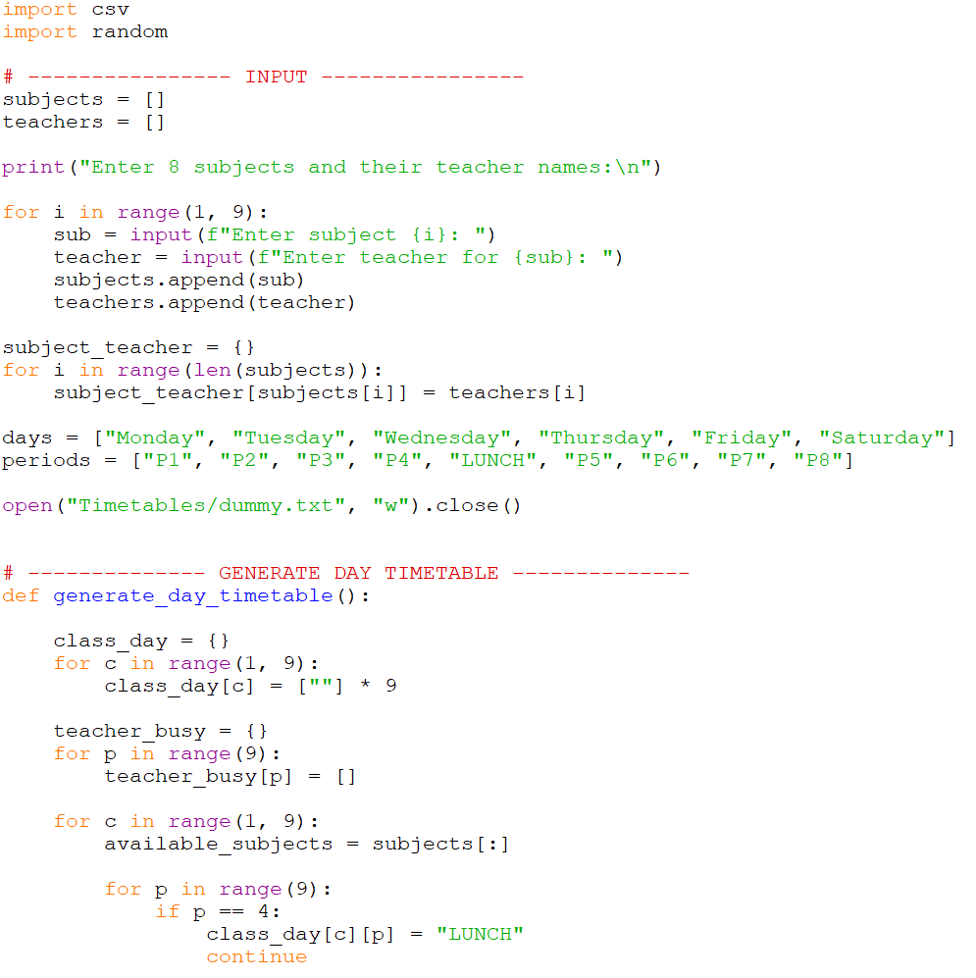
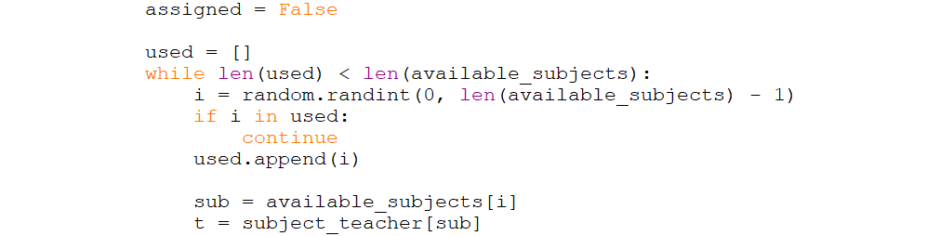
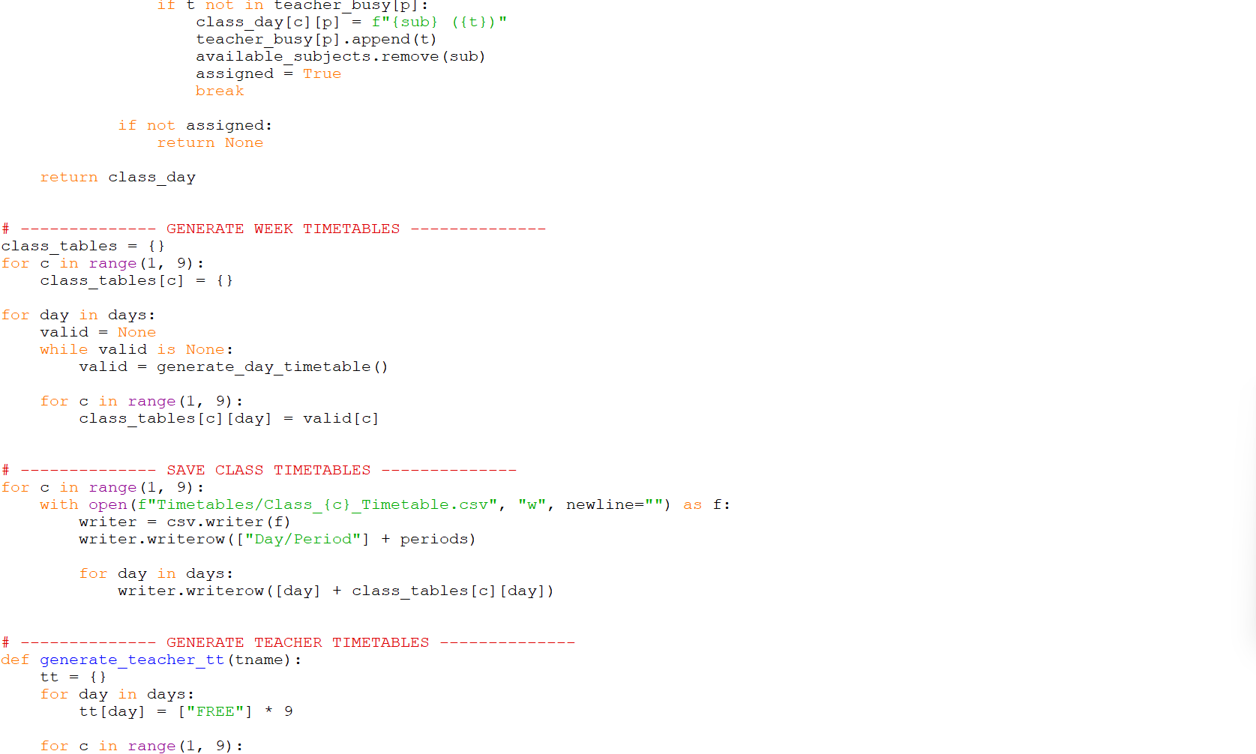
6
7
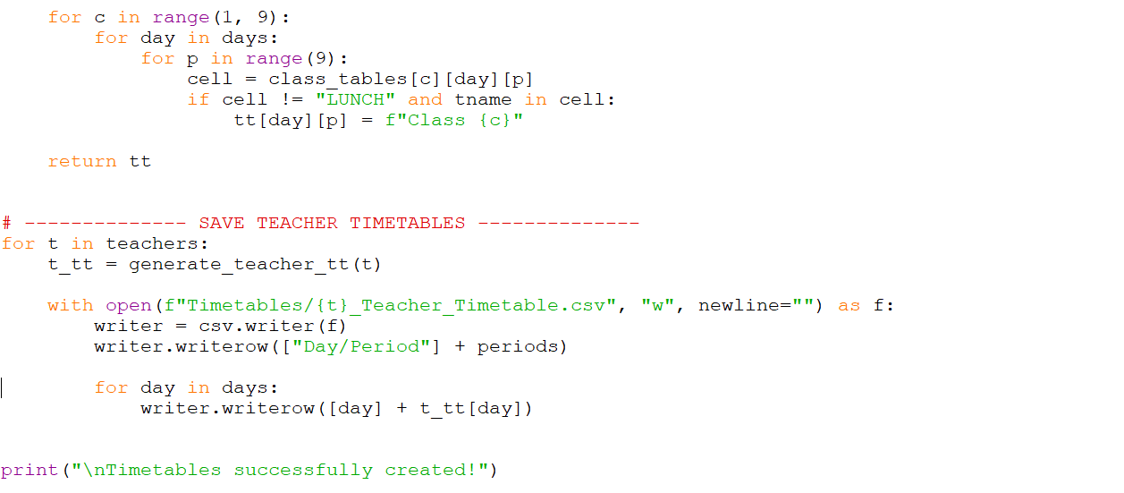
8
PYTHON CODE INPUT
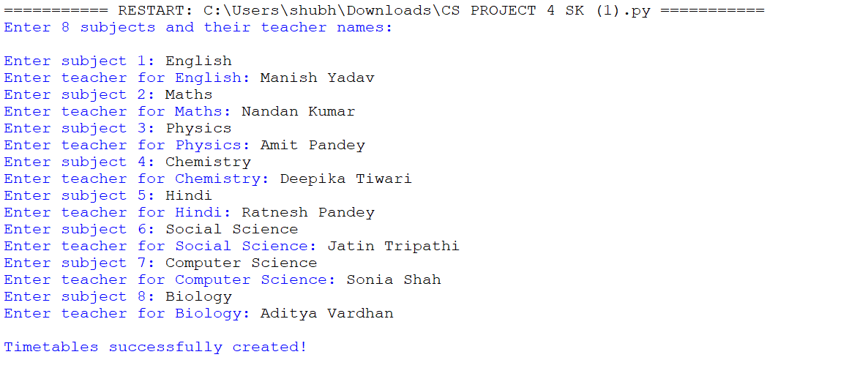
9
OUTPUT
Teachers Timetables -
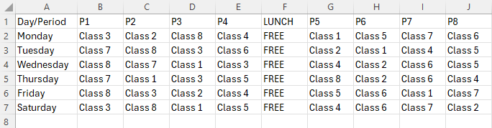
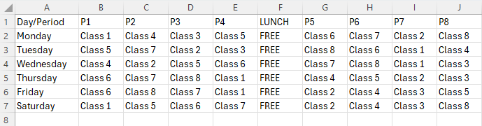
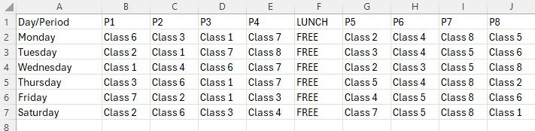
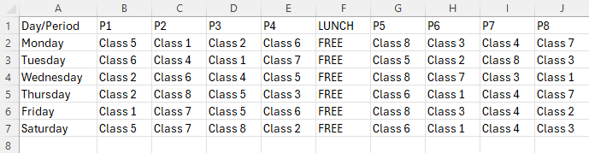

10

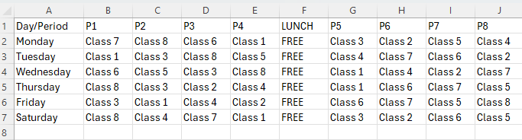
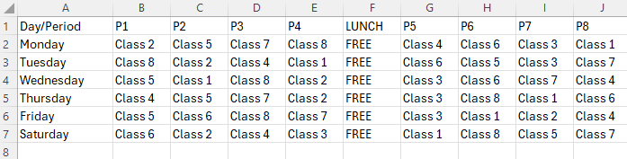
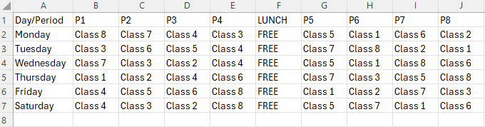
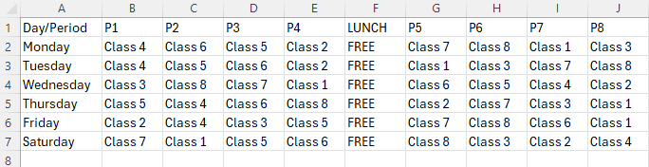

11
Classes Timetables -

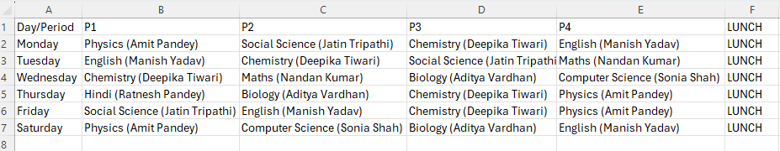
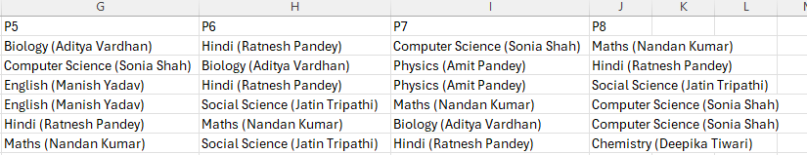

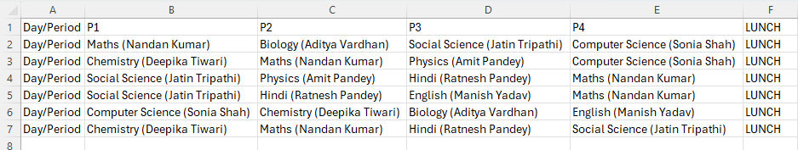
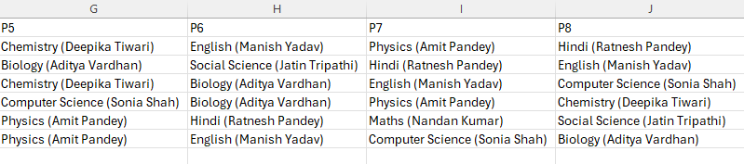
12
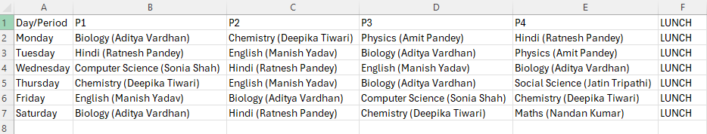
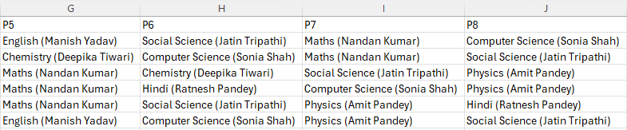
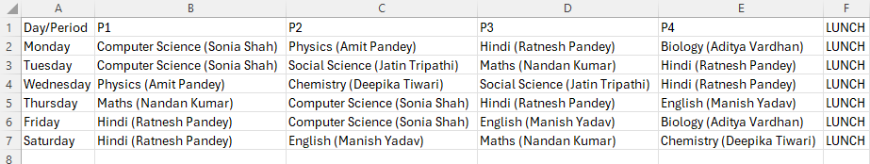
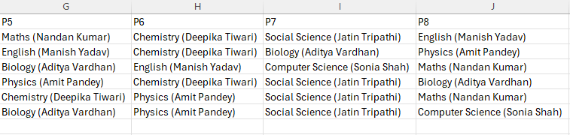
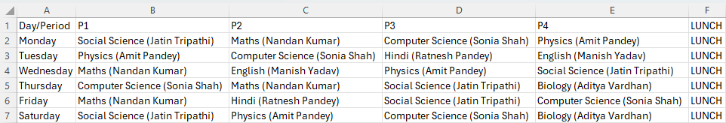
13
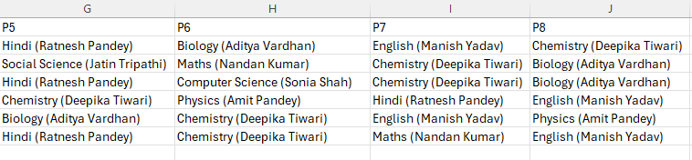
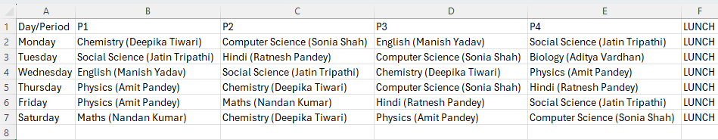
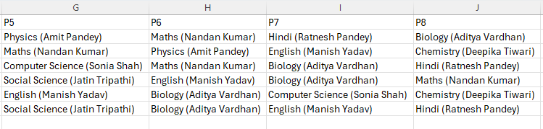
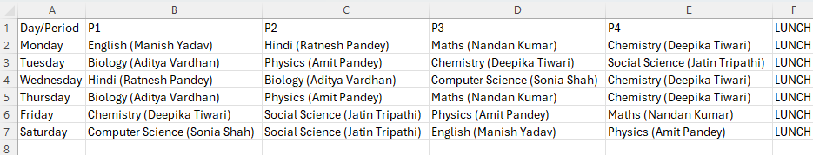
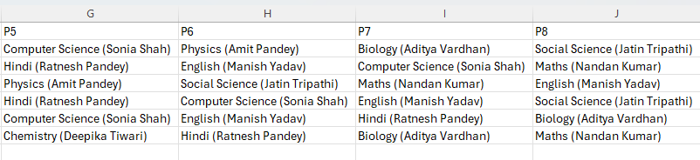
14
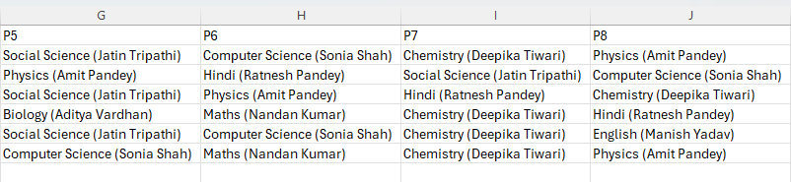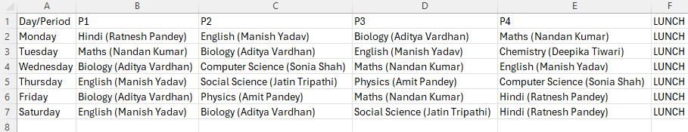
FEATURES OF THE PROJECT

- Automatic timetable generation
- Prevents teacher clashes across classes
- Fixed lunch break included
- Generates separate timetables for:
- Each class
- Each teacher
- Output stored in CSV format (Excel-compatible)
- Easy to modify subjects and teachers

15
LIMITATIONS OF THE PROJECT

- Number of subjects and classes is fixed
- Does not consider teacher availability preferences
- No graphical user interface (GUI)
- Timetable generation depends on randomization
- Folder must be created manually before execution

16
BIBLIOGRAPHY

- NCERT Computer Science Textbook – Class XII
- Python Official Documentation
- CBSE Computer Science Syllabus (2024–25)
- Microsoft Excel Documentation
- Online Python learning resources
17

